PHYSIOLOGY OF HEARING

Definition:
Hearing is the sensation of sound.
MECHANISM:
The hearing ( auditory ) system is divided into two components:
- Conductive component.
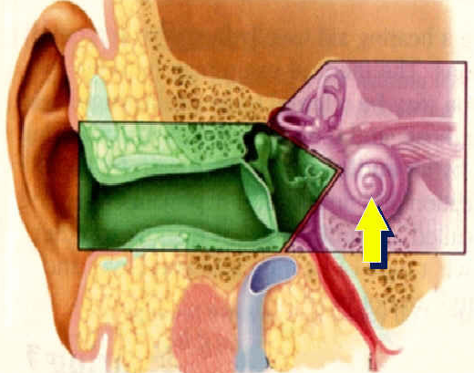
- Sensori-neural component.
1. The Conductive Component
It transmits sound waves as vibrations.
It consists of the External ear and the Middle ear.
A- THE EXTERNAL EAR:
A- The auricle: Collects the sound waves & directs them to the external auditory canal.
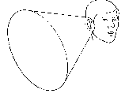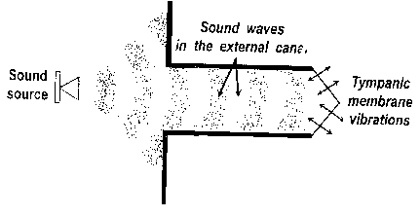
B- The external auditory canal
Transmits the sound waves to => the tympanic membrane.
C-When the sound waves reach tympanic membrane it vibrates.
B-THE MIDDLE EAR CLEFT:
The middle ear ossicles:
- They vibrate and transmit the sound waves from the tympanic membrane to the oval window.
- They amplify sound waves by two mechanisms (impedance matching):
- Areal ratio => between the vibrating area of the tympanic membrane
and the area of the footplate of stapes. It is 17: 1.
- Lever ratio => between the arm of malleus ( its handle )
and the arm of incus ( its long process). It is 1.3:1
The overall amplification is 17x1.3 = 22
i.e. the intensity of sound at the oval window => is 22 times that at the tympanic membrane.
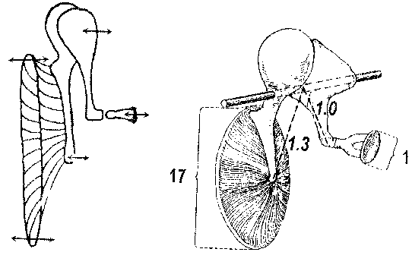
The middle ear muscles:
They protect the inner ear from the harmful effect of loud sounds. How? Exposure to loud sounds => reflex contraction of these rnuscies => limits vibration of ossicles => reduces sound conduction.
The Eustachian tube
- It ventillates the middle ear => to equalize the middle ear & atmospheric pressure: This is important for proper vibration of the tympanic membrane and ossicles
- It drains the middle ear.
2. The Sensori-neural Component
- It transmits sound waves as electrical impulses.
- It consists of the Cochlea and the Cochlear nerve.
A-THE COCHLEA:
Converts the sound vibrations => to electrical impulses by vibration of the footplate of stapes in the oval window leading to vibration of the cochlear fluids and vibration of the basilar membrane this produces stimulation of the cochlear hair cells which lie on the basilar membrane (in the organ of Corti) and conversion of the mechanical sound vibrations to electrical impulses.
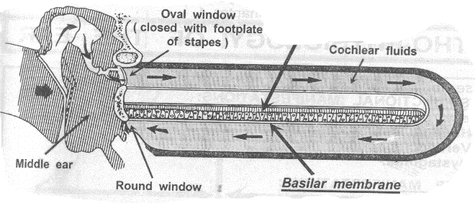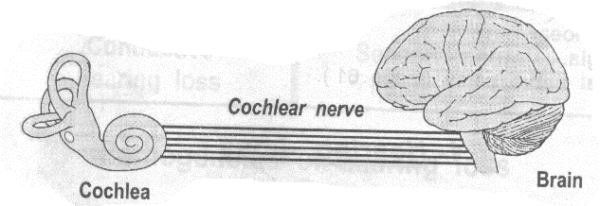
B-THE COCHLEAR NERVE:
Transmits the electrical impulses to the cochlear nuclei (in the brain stem).
PHYSIOLOGY OF EQUILIBRIUM

- Maintenance of balance occurs in three steps
- Initially the brain receives sensory information from three sources
- The vestibular part of the inner ear
- Vision
- Proprioception of muscles, joints and tendons
- Then the brain integrates these sensory information
- Then the brain sends motor orders to two groups of muscles
- The extraocular muscle: to keep eyes stable
- The spinal muscles: to keep the limbs and trunk stable
